Explore Maths
Hands-on Mathematics Exhibition from MathsWorld UK
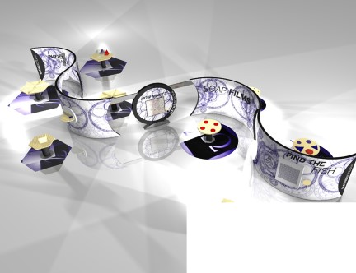  Explore Maths Concept Art November 2019  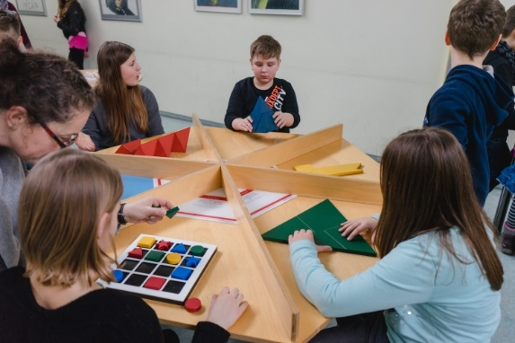 | Explore Maths invites all visitors to take a first-step into the world of mathematics.  The exhibition is made from plywood to create a visually stunning ribbon. It features several mounted activities and eight table activities.  Three cut-out circles allow people to move freely between activities, including wheelchairs. Other arrangements are possible, such as installing the ribbon as two halves.  Footprint: 12m × 21m including tables and floor mats. Other arrangements are possible.  Height: 2.55m  Installation time: 1 day  Costs: £3000 (travel and installation costs only)  Target age: Family friendly with activities even toddlers can take part in and adults can be absorbed by. Mathematically accessible to Y5-Y8 school parties.  Group size: 30-40 (60 max)  Duration: 60 minutes
The exhibition features over 20 high quality activities from Mathematikum, Germany’s national mathematics discovery centre, plus some of our other favourite interactives.
 | Picture | Description
1. | 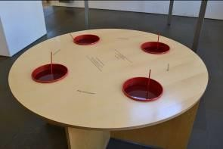 | Wonderful Soap Films  Differently shaped metal frames are to be plunged in soap sud. Beautiful soap films emerge – minimal surfaces fascinating us with their beauty.  Technical information:  Dimensions: diameter 1200mm, height 835mm Red buckets, red metal frames  Surface birch multiplex with applied label
2. | 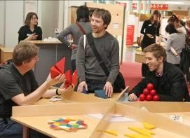  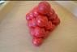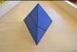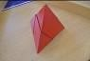  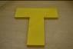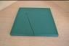 | Puzzle Table 1  This is a collection of different famous puzzles on the hexagonal puzzle table known from the Mathematikum: T-Puzzle, 2 Pieces Pyramid, 4 Pieces Pyramid, Ball Pyramid, Square-Triangle  Technical information:  Dimensions: ca. 835*1700*1435mm In part with anti-slip covering  Use of 6 chairs is recommended
3. | 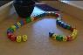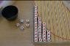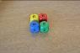  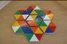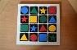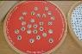 | Puzzle Table 2  With the following exhibits:  Queue of Dice, Red Dice Out, The Second Will Be First, Honeycomb Puzzle, Colored Pieces, Secret Code  Technical information:  Dimensions: ca. 835*1700*1435mm
4. | 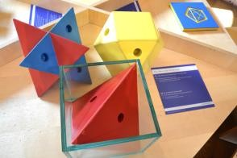 | What Fits into a Cube  Three solids can be fit into the cube.  The exhibit consists of a table with a glass cube and three different solids. The solid set consists of:  1 x tetrahedron in red  1 x stella octangula in blue  1 x cubeoctahedron in yellow
5. | 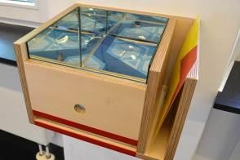 | Mirror Box – Infinite Patterns  If a figure is placed inside the box in which the sides are internally equipped with a mirror, we can see infinte patterns.  Exhibit can be placed on a table or fixed on a wall.
6. | 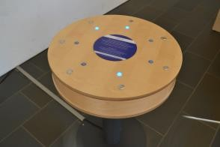 | Lights On!  The task is to light up all seven lamps at the same time, but each switch affects the state of three lamps: those that were turned off are switched on and vice versa.  Exhibit on a metal stand
7. | 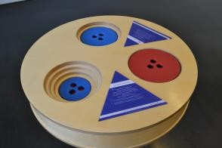 | The Tower of Ionah  The visitor is supposed to move the five discs of one tower to another tower with as few moves as possible.  Exhibit on a metal stand
8. | 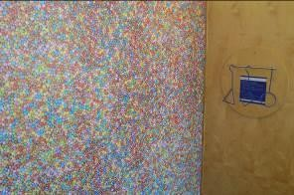 | The Smarties  You are able to guess the approximate number of the Smarties on a poster by counting the smarties in a small area.  Board with pattern print, metal differently shaped templates and hanger.
9. | 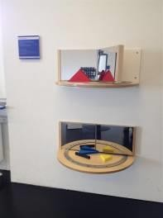 | A Machine for Patterns (Mirror Book)  With this exhibit you can experience the correlation between the angle between two mirrors and the amount of reflections in the mirrors.  The exhibit consists of 1 mirror book that can be fixed on a wall or on a table.
10. | 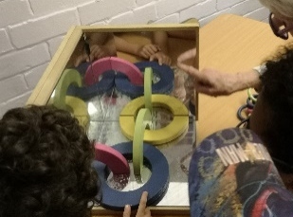 | Corner Mirror with 12 Ring Puzzle  No matter from which point you look into this mirror: you will always see yourself. Light beams are always reflected in parallel beams. An exhibit with many applications, e.g. the reflector on a bicycle.
11. | 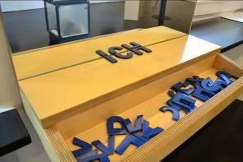 | Symmetric Letters  "Halved letters" can be complemented into full, legible ones, by placing them in front of a mirror: The reflection supplements the missing parts.  Technical information: Dimensions: ca. 280*500*250mm Wall attachment
12. | 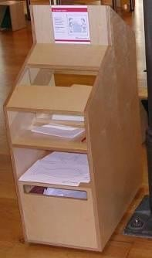 | Drawing in the Mirror  It can’t be that difficult to retrace the outlines of a star or a fish. But this exhibit is a challenge to both children and adults! If you only see the images in the mirror, this apparently simple task becomes very tricky.  Technical information:  Dimensions ca. 1100*400*700mm  Installation with two areas for drawing (different heights), two areas for new paper and one “trash box” for the used papers.
13. | 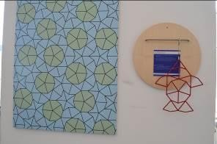 | Who Finds the Fish?  The visitor is supposed to find the shape of a fish within a Penrose tiling. There is only one place where the fish fits.  Board with pattern print, metal fish shaped template and hanger.
14. | 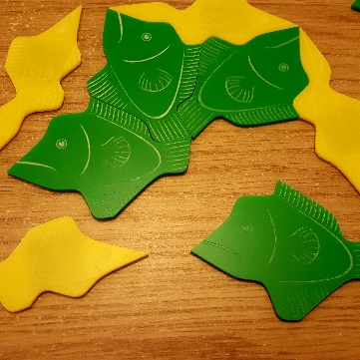 | Penrose Fish Tessellation Station  Two fish shapes tesselate to make non-repeating patterns.  Wall Mounted
15. | 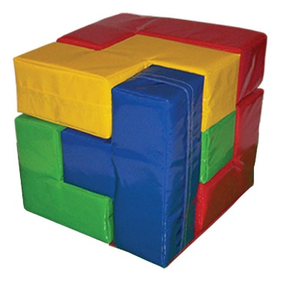 | Giant Soma Cube  An enduring brain-teaser for both children and adults. It is made of seven pieces and assembling them into a large cube can be done in hundreds of ways. Can you find one?  The size of the Soft Play Soma Cube (Small) is 600mm × 600mm × 600mm.
16. | 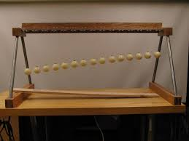 | Pendulum Wave  Pendulums of different heights are released together. Each pendulum has a different period which creates ever-changing patterns of synchronicity.  Table activity
17. | 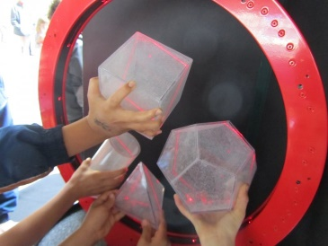 | Ring of Fire  Place various Perspex shapes into the laser ring to reveal its cross section.  Table activity
18. | 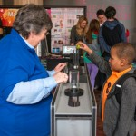 | Parabolic Bounce  Drop a ball on the parabola and it will always hit the same mark, known as the focal point.  Table activity
19. | 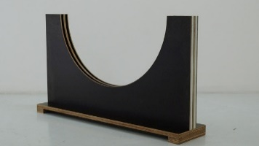 | Tautochrone
20. | 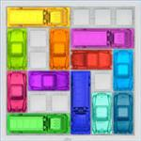 | Giant Rush Hour Game  A giant version of the ThinkFun game. A sliding block logic game, you have to battle the gridlock as you slide the blocking vehicles out of the way for the red car to exit.  Table activity
21. | 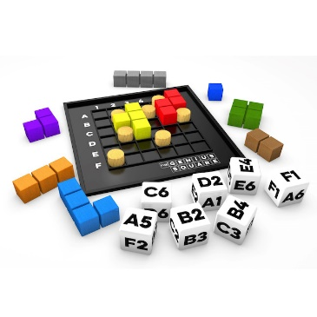 | Giant Genius Square  A giant version of the Happy Puzzle Company Game  Roll the Dice & Race Your Opponent To Complete The Square! The aim of each of the 62,208 possible puzzles is to complete the square using the nine coloured shapes, once the seven ‘blockers’ have been positioned. There may be times when it seems impossible, but amazingly, there will ALWAYS be at least one solution.  Table activity
22. |  | Puzzle Apps from the Open University  Various puzzles on ipad screen, set on a separate stand. Height 1m.

