Maintenance

Before opening check whether all pieces are there. This applies in particular for the puzzle tables and “Drawing in the mirror”.
In the following “cleaning“ means using all-purpose cleaner.

 | Activity | Pieces | Cleaning | Additional | Activity duration
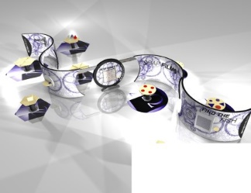 | General | Large display. Six tables. Three plinths. 8 mats.
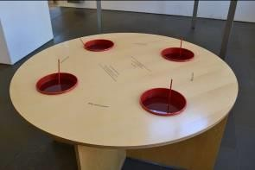 | Soap Film  Dip different frames into soapy water to explore the different shapes they make. | One table, with four buckets set into the table.  Four wire frames. | Regularly clean table  change liquid (at least every second day)  at least once a week clean models and buckets | Soap water recipe:  1 litre of warm water  250ml of Fairy liquid (Fairy liquid is best for good quality mixture)  Mix gently. | 3 minutes
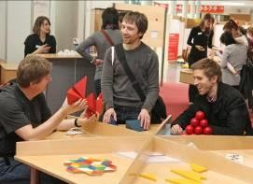  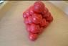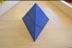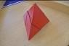  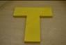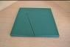 | Puzzle Table 1  Five geometric puzzles:  Ball pyramid.  2-piece pyramid.  4-piece pyramid.  T-puzzle.  Square-triangle. | Ball pyramid: 4 red pieces  2-piece pyramid: 2 blue pieces  4-piece pyramid: 4 red pieces  T-puzzle: 4 yellow pieces  Square-triangle: 4 green pieces | Clean table and pieces once a day | Puzzles need to be occasionally reset, and checked all pieces are there.  Pieces are large and we don’t expect pieces to be accidentally lost or taken. | 3 - 10 minutes each
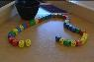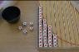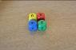  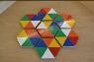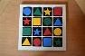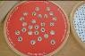 | Puzzle Table 2  Three dice puzzles. Two colour puzzles. Code puzzle.  Queue of dice.  Red dice out.  Second will be last.  Honeycomb puzzle.  Coloured pieces.  Secret code. | Queue of dice: 20 dice.  Red dice out: 39 dice  Second will be last: 4 large dice.  Honeycomb puzzle: 7 pieces. Middle piece fixed.  Coloured pieces: 4x4 grid. Fixed to table. 16 colour pieces.  Secret code: Circle. Fixed to table. Red grille, removeable. | Clean table and pieces once a day | We will provide spare dice for queue of dice, and red dice out. | 3 - 10 minutes.
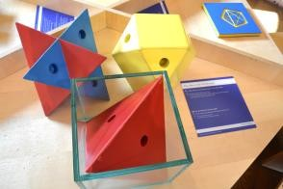 | What fits in a cube  Can you fit these shapes into the glass box. | Glass box  Three large solid shapes (red tetrahedron; yellow cubeoctahedron; blue Kepler Star). | Clean table and pieces once a week  Clean cube with glass-cleaner once a day |  | 3 - 8 minutes
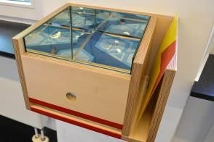 | Mirror Box – Infinite patterns  Slide patterns into slot and view infinite patterns. | Mirror box. 4 slides. | Clean pieces once a week  Clean mirrors with glass-cleaner (at least) once a day |  | 2 - 5 minutes
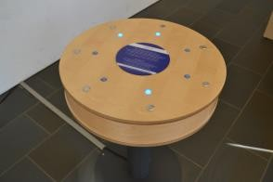 | Lights On  Logic problem. Press buttons to turn all lights on. | Stand-alone exhibit. | Clean surface once a week | Needs power. | 5 minutes
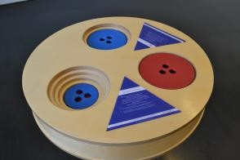 | Towers of Ionah  Move all discs from one hole to another. Classic puzzle. | Stand-alone exhibit  Two red discs, two blue discs. | Clean pieces once a week |  | 5 minutes
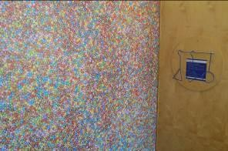 | How Many Smarties  Estimation and sampling problem. Take guesses. Uses frames to take a sample. | Poster: Wall mounted.  4 frames (square, triangle, rectangle, circle).  Hanging bar and hook | Clean picture and pieces once a week | Can be a group lead activity. Perhaps to introduce a group to exhibition. | 5 minutes
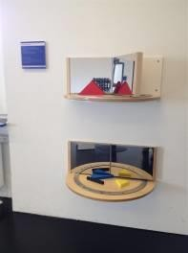 | Mirror Book  Move the mirrors to create different patterns and different number of reflections. | Mirror Book  Two foam triangle pieces  One stick | Clean pieces once a week  Clean mirrors with glass-cleaner (at least) once a day |  | 2 minutes
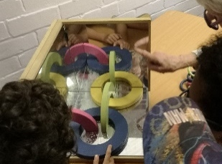 | Corner Mirror (12 ring puzzle)  Can the pieces be placed on the mirrors to create a circle of 12 linked rings | Corner Mirror  Foam rings.  1 blue ring.  1 yellow half ring.  1 green half ring.  1 red quarter ring. | Clean pieces once a week  Clean mirrors with glass-cleaner (at least) once a day | Spare pieces can be provided. | 2 – 5 minutes
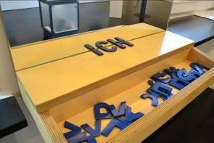 | Symmetric letters  Create words with symmetric letters | Assorted letters. | Clean pieces once a week  Clean mirrors with glass-cleaner (at least) once a day | Spare letters are available. | 2 – 8 minutes
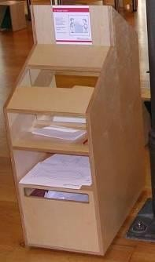 | Drawing in the mirror  Can you trace the shapes while only looking in the mirror? | Stack of printed fish and star shapes (A4 paper).  Pencils | Clean surface at least once a week  Clean mirrors with glass-cleaner (at least) once a day | New printing can be provided. | 5 minutes
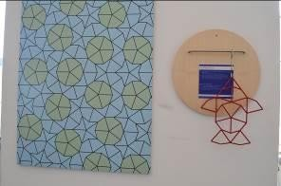 | Find the Fish  Use the fish frame to find the fish shape in the poster. | Poster: Wall mounted.  Fish frame.  Hanging bar and hook. | Clean fish and the picture once a week |  | 3 - 10 minutes
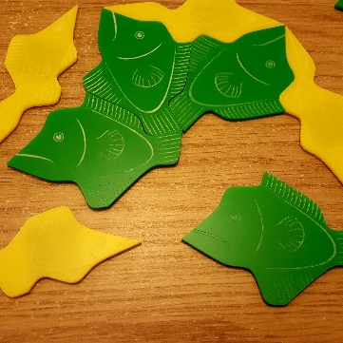 | Penrose Fish  Tesselate the magnetic fish to create patterns. | Green fish shapes. Yellow fish shapes. | Clean pieces once a day | Spares are available. | 2 - 5 minutes
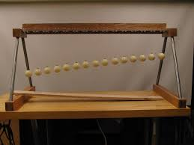 | Pendulum Wave  Turn the handle to set the pendulums, and release. Pendulums create patterns as they synchronise. | Stand-alone exhibit on table. | Clean handle at least once a day. Clean surface at least once a week |  | 2 minutes
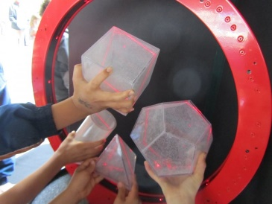 | Ring of Fire  Place Perspex shapes into the ring. The laser shows you the cross section. | Table.  Ring of fire (ring laser)  Perspex solids (cube, cylinder, cone, tetrahedron, dodecahedron) | Clean surface and pieces at least once a week | Needs power. May need supervision. | 5 – 8 minutes
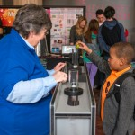 | Parabolic bounce  Release the ball to hit the focal point. | Stand-alone exhibit. One ball. | Clean surface at least once a week |  | 3 minutes
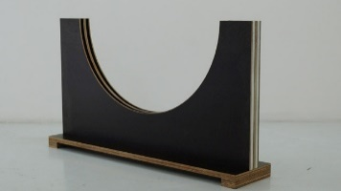 | Tautochrone  Release two discs from any two points on opposite sides. They will always reach the middle at the same time. | Curve and stand. Two discs. | Clean surface and pieces at least one a week. |  | 3 minutes
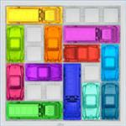 | Rush hour game  Puzzle. Slide the red car out of the traffic jam. | Table. 12 cars. | Clean table and pieces once a day |  | 5 – 10 minutes
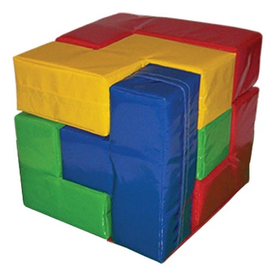 | Giant Soma Cube  Make a large cube | 9 pieces.  1 mat. | Clean surface at least once a week |  | 5 – 10 minutes
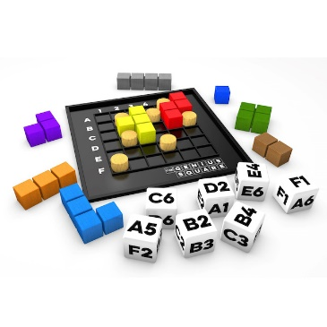 | Genius Square  Place the blockers (pegs) on the grid. (Optionally, use the dice to determine placement). Fill the remaining space with tetris shapes. Race a friend. | 7 pegs.  9 tetris shapes  7 dice (optional) | Clean table and pieces once a day |  | 5 minutes
 | Ipad (puzzle app) and stand.  Stand may be knocked over if not fixed. | 1 stand  1 ipad | Clean surface at least once a day | Needs power. | 3 – 10 minutes

