Risk Assessment Form

Equipment / Activity / Area being assessed | Explore Maths Exhibition | Risk Assessment No
Location | Winchester Science Centre | COSHH assessment
Who is exposed? | General public
Date of assessment | 20-03-2020
Assessor’s name and job title | James Grime Touring Manager

Risk = Likelihood of injury x Severity of injury | R = L x S | Low risk = 0 – 6 | Medium risk = 7 - 12 | High risk = 13 - 25

 |  | S = Severity of injury
 |  | No injury or illness (0) | Minor injury or illness (1) | First aid injury or illness (2) | “3 day” injury or illness (3) | Major injury or illness (4) | Fatality, disabling  injury, etc (5)
L = Likelihood of injury | Zero to very low (0) | 0 = Low | 0 = Low | 0 = Low | 0 = Low | 0 = Low | 0 = Low
 | Very unlikely (1) | 0 = Low | 1 = Low | 2 = Low | 3 – Low | 4 = Low | 5 = Low
 | Unlikely (2) | 0 = Low | 2 = Low | 4 = Low | 6 = Low | 8 = Medium | 10 = Medium
 | Likely (3) | 0 = Low | 3 = Low | 6 = Low | 9 = Medium | 12 = Medium | 15 = High
 | Very likely (4) | 0 = Low | 4 = Low | 8 = Medium | 12 = Medium | 16 = High | 20 = High
 | Almost certain (5) | 0 = Low | 5 = Low | 10 = Medium | 15 = High | 20 = High | 25 = High

 | Hazard | Control Measures already in place to control the risk | What additional Control Measures are required? | Risk rating (High, Medium, Low) | Completed/ Escalated to:
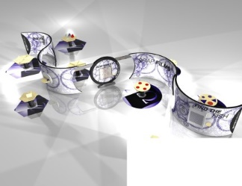 | General  Large display background. Sturdy and fixed. Tables, plinths, exhibits. Knock into, knocked over, swung on by younger children. | Exhibits fixed to plinths. Stand-alone exhibits with heavy base. | Discourage children from running, swinging etc | 0
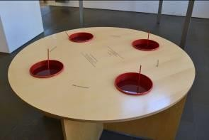 | Soap Film  Uses soapy water. Spillages will occur. | Buckets are fixed into the table. Table is heavy. Table on a mat. | Spillages on floor need to be wiped by staff and signage used accordingly. | 1
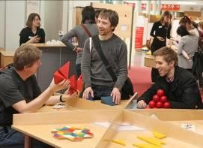  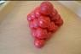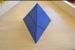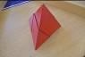  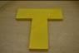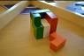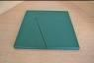 | Puzzle Table 1  Puzzle pieces. These pieces are large and are not a choking hazard. | N/A | N/A | 0
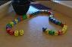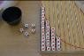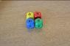  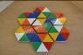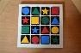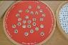 | Puzzle Table 2  Puzzle pieces are large.  Dice are larger than average. Unlikely choking hazard. | N/A | N/A | 0
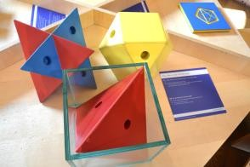 | What fits in a cube  A table and a robust, glass box. | Glass box is robust but should be kept away from edge of table. Can be fixed down if necessary. | Staff should keep away from edge of table. Can use double sided tape to fix to table if necessary. | 0
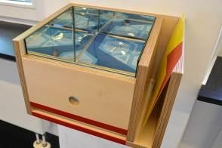 | Mirror Box – Infinite patterns  No perceived risks | Box to be fastened down on a plinth. | N/A | 0
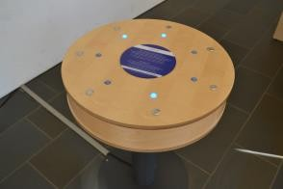 | Lights On  Exhibit on metal stand. Potential risk of being knocked over. | This is a very solid base. Tried and tested at mathematikum. | N/A | 0
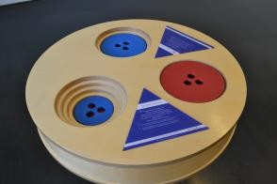 | Towers of Ionah  Exhibit on metal stand. Potential risk of being knocked over. | Solid base. Tried and tested at mathematikum | N/A | 0
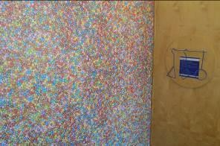 | How Many Smarties  No risk | N/A | N/A | 0
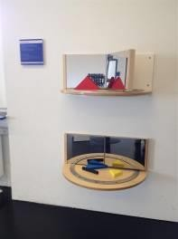 | Mirror Book  Trapped finger risk | Leave shapes between mirrors. | Leave shapes between mirrors. | 1
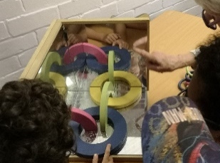 | Corner Mirror  No risk. | Will be fastened down. | N/A | 0
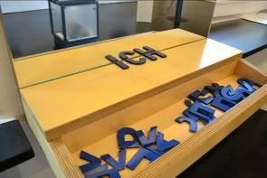 | Symmetric letters  No risk | Will be fastened down. | N/A | 0
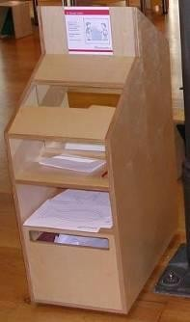 | Drawing in the mirror  No risk | N/A | N/A | 0
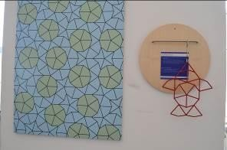 | Find the Fish  No risk | N/A | N/A | 0
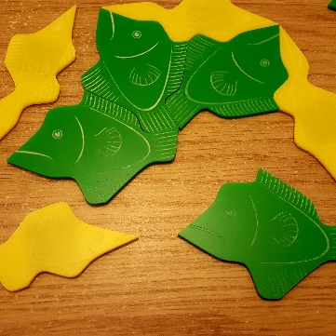 | Penrose Fish  No risk | N/A | N/A | 0
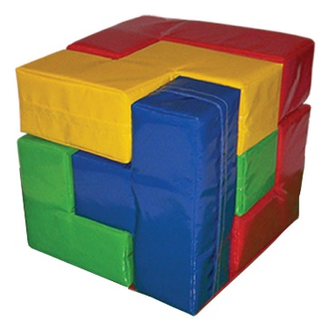 | Giant Soma Cube  Young children may climb on the pieces and fall | Discourage children from climbing on cube. | Discourage children from climbing on cube. | 1
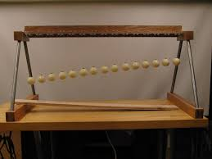 | Pendulum Wave  No perceived risk | N/A | N/A | 0
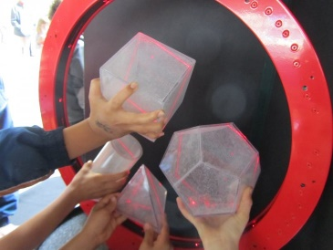 | Ring of Fire  Laser used in the ring. | Ring is placed on table lasers vertical and therefore user cannot look into laser directly without climbing on table and lying on it. | May need to be accompanied | 1
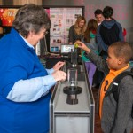 | Parabolic bounce  No perceived risk | N/A | N/A | 0
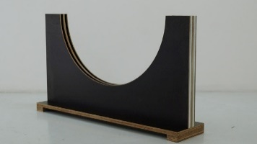 | Tautochrone  No perceived risk | N/A | N/A | 0
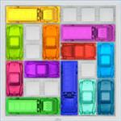 | Rush hour game  Game pieces. No choking hazard | N/A | N/A | 0
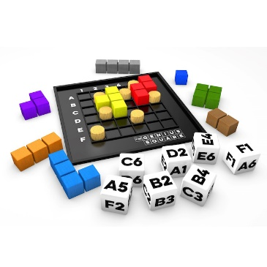 | Genius Square  Dice and game pieces. Unlikely choking hazard. | Signage, not suitable for children under 3. | Direct younger children to other activities. | 1
 | Ipad (puzzle app) and stand.  Stand may be knocked over if not fixed. | Stand to be fixed. | N/A | 0

Sign-off of risk assessment
Reviewed by Operations Team on:
Next Review date:

