Teacher Guide

Officially, Explore Maths is an interactive exhibition exploring problem-solving, shape and probability.

However, our real aim is to change attitudes to maths. This is a place for visitors (of all ages) to explore maths for themselves, in a relaxed, low-pressure atmosphere.

There are things to learn from each activity, but we do not want to burden the visitor with the weight of expectation. There is no pressure to take away certain facts. We want visitors to enjoy playing and experimenting with the exhibits. What they learn is whatever they discover for themselves. However, we have included some advice below to help guide a visitor’s exploration.

Success is whether a visitor has spent time playing with maths that they wouldn’t have done otherwise.

The touring exhibition website has more information about each exhibit including some deeper maths; history; applications and activities to try at home http://mathsworlduk.com/touring-exhibition

Explore Maths is a first-step into the world of mathematics, and a welcoming place to play.

Activity | Instructions | Tasks | Teachers | Activity duration
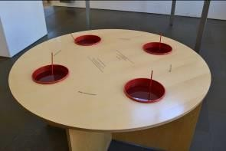  Soap Film  Dip different frames into soapy water to explore the different shapes they make. | Soap films  Dip the frames into the soapy water – what shapes do they make?  How many faces meet at one edge? | Dip the frames into the soap water.  Explore the shapes they make.  Try a new frame. Try to predict what will happen.  Was your prediction correct?  How many soap faces intersect at an edge? How many soap faces intersect at a point? What angles do they make? | Soap water has elastic skin to make itself as small as possible. Dip the frames in the soap water and see what shapes occur. After trying a few frames, can the student predict what will happen? More able students may see that three soap films always meet at an edge and six soap films always meet at a point. This makes the surface area as small as possible. This has applications in architecture and is seen in art. | 3 minutes
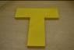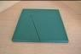  Combine the yellow tiles to make a T. Combine the green tiles to make a square or an equilateral triangle. | The T  The four yellow pieces form a big T.  Hint: How is the right angle used?  The Square-Triangle  The four green pieces fit together to form either a square or an equilateral triangle. | Square-Triangle: Can you combine the four green pieces to form a square?  Square-Triangle: Can you combine the four green pieces to form an equilateral triangle?  The T: Can you combine the four yellow pieces form a big T? Hint: How is the right angle used?  What other shapes can you make? Can you make an arrowhead? | These geometric puzzles only use a few pieces but can be quite challenging. The easiest is to use the four green pieces to form a square, finding the right-angles help here. Slightly harder is to use the same green pieces to make an equilateral triangle, this time the right-angles must be internal.  The T puzzle is deceptively difficult: use the four yellow pieces to make a T. The 5-sided shape contains a right-angle, but the right-angle is an external angle, where the horizontal and vertical lines of a T meet, and should not be filled. A student might enjoy exploring what other shapes can be made from the pieces. Can they make an arrowhead? | 3 - 10 minutes each
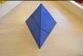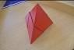  Combine the pieces to make a tetahedron | 2-piece pyramid  Combine the two blue pieces to form a pyramid.  Hint: What happens to the square face on each piece?  4-Piece Pyramid  Combine the four red pieces to form a pyramid.  Hint: Two small red pieces can be put together to form a piece of the blue pyramid. | Combine the two blue pieces to make a pyramid. Hint: What happens to the square face of each piece?  Combine the four red pieces to make a pyramid. Hint: Two small red pieces can be put together to form a piece of the blue pyramid.  With the 4-piece puzzle we can see one cross-section of the tetrahedron is a square. What is the other cross section? | Combine the two blue pieces to form a pyramid (tetrahedron). Since a tetrahedron is made of four triangular faces, what happens to the square faces? The two pieces must meet at their square faces, making the square hidden inside the tetrahedron. In fact, the square is a cross-section of the tetrahedron.  For the 4-piece pyramid, two red pieces can be combined to make one of the blue pieces, then solved as before. We can now see two cross-sections of the tetrahedron, a square and a triangle. | 3 - 5 minutes each
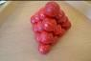  Combine the pieces to stack the balls in a pyramid | Ball pyramid  Put the four pieces together to form a pyramid.  Hint: Where can you place the long pieces?  Such a pyramid is called a “tetrahedron”, meaning it has four (triangular) sides. | Put the four pieces together to form a pyramid. Hint: Where can you place the long pieces?  A pyramid (tetrahedron) of side length 4 contains 20 balls. How many balls would be in a pyramid of side length 5?  How many balls would be in a pyramid of side length 12? Is there a general way to work it out? | Combine the pieces to make a pyramid (tetrahedron). Each face of the pyramid is a triangle of side length 4, containing a row of 4, a row of 3, a row of 2 and a row of 1. There is only one way the pieces can be stacked to make these rows. How many balls would be in a pyramid of side length 5? Or 12? | 3 - 10 minutes.
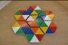  Honeycombs  Match the colours to complete the honeycomb. | Honeycombs  Arrange the hexagons and match their colours around the fixed hexagon. | How many colours can you match around the centre hexagon?  Can you match all six free hexagons around the centre hexagon?  How many possible ways are there to arrange the hexagons? | In this puzzle you need to match the colours around the centre hexagon. It may seem like there is a large number of possibilities, but many of our choices are forced because we need to match colours. In fact, there are fewer than ten possibilities to check, which only requires the solver to be patient and systematic. There is only one solution. | 3 - 10 minutes.
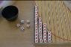  Red Dice Out  An example of exponential decay. | Red dice out  Roll all the dice and put any dice with a red face on top in the first column.  Roll the remaining dice, and put any new red dice in the second column. Repeat this way until there are no dice remaining.  Before each roll can you predict how many of the dice will be red? | Do the dice follow the predicted curve?  What proportion of dice will be red each time?  If I start with 100 dice, how many blue dice will be left after five rolls?  If I have 20 blue dice left after ten rolls, how many dice did I start with? | Roll the dice, place the red dice in the first column, then repeat with the remain dice. The number of red dice after each roll should follow the predicted curve. After each roll one-third of the dice should be red. This is an example of exponential decay, which is found in many natural such as radioactive decay.  Although we cannot predict what happens to each individual die, we can make general predictions about the dice as a whole. | 3 - 10 minutes
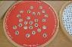  The Secret Code  An introduction to secret message, i.e. codes, ciphers, cyptography | The secret code  Turn the disc until you are able to read a message. The message is written line by line.  This type of code is called a “grille cipher”. | Turn the wheel to find a secret message. The message is written line-by-line. There is more than one message to find!  This type of code is called a “grille cipher”. Can you make a grille cipher of your own?  Can you devise your own way to send a secret message? | Find the hidden message by turning the red grille. There is more than one message to find. Other ways of hiding messages include invisible ink or microdots. The art of hidden messages is called steganography. Today messages can be hidden in the 1s and 0s of digital images. Codes and ciphers are other ways to send secret messages. | 3 - 10 minutes
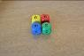  Second will be First  A counter-intutive dice game. | Second will be first  This is a game for two players.  Each player picks a die. Roll the dice together and whoever has the highest number wins. After ten rolls decide which die is best.  Try a different pair of dice and see which die is best this time.  If you choose second, you can always pick a die with a better chance of winning. | Roll a die each and whoever rolls the highest number wins. Play best of ten games. Which die is best?  Can you determine which die beats which? What strange thing do you notice?  Can you work out the probability of winning for each die? | A game for two players. Pick a die each and roll to see who gets the highest value. Play best of ten games. Which die is better? Try again with another pair, which is die is better this time? It turns out that, no matter which die your opponent chooses, there is always a die that beats it. The dice form a circle of victory, like rock-paper-scissors. | 3 - 10 minutes
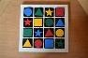  Coloured Pieces  A sudoku-style puzzle | Coloured Pieces  Arrange the pieces so that every row and column contain each shape and each colour. | Arrange the pieces so that every row and column contain one piece of each shape (or colour).  Arrange the pieces so that every row and column contain one piece of each shape and one piece of each colour.  How many solutions are possible? What about grids of other sizes? | This puzzle is similar to a Sudoku and is called a Graeco-Latin square. There are many solutions, but all solutions have the same structure.  Optionally, the puzzle can be easier to solve if we say that the two diagonals must also contain one piece of each shape and colour.  For younger visitors, try to arrange the pieces so that every row and column contain one piece of each shape (or colour). | 3 - 10 minutes
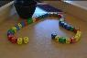  Queue of Dice  We can predict the most likely end die. | Queue of dice  Roll all the dice and place them in a row.  Select any of the first six dice. Read its number, then count that number of places down the row until you land on a new dice. Read the new number and repeat the process until there are no longer enough dice. Remember the last die you landed on.  What happens if you or a friend select a different starting die? | Try the experiment again with a different starting die. What do you notice?  Try the experiment again with a pack of cards, with Jack, Queen, King worth 5. Can you predict which card a friend will land on? How about if Jack, Queen, King are worth 11, 12, 13?  Can you explain why different starting choices result in the same answer? Does this work every time? | Place the dice in a row. Choose one of the first six dice and use that number to count down the line until you land on a new die. Repeat until you run out of dice and remember the last die you landed on. Try again with a different starting die. It is highly likely that the you end on the same die as before. This is because the paths eventually synchronise. This doesn’t always work but, with 20 dice, does so with a probability of 80% | 3 - 10 minutes
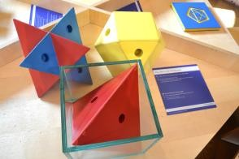  What fits in a cube  Can you fit these shapes into the glass box. | What fits into a cube  Each of these solids fit perfectly into the cube.  The solids are called tetrahedron, Kepler’s star and cuboctahedron.  Hint: For each solid there is a trick:  Tetrahedron: concentrate on one of the edges.  Kepler’s star: in how many directions does the star point?  Cuboctahedron: how many squares does the solid have? | Each solid fits perfectly in the glass cube. Can you fit the red tetrahedron in the cube? Hint: How many edges does the tetrahedron have?  Can you fit the blue Kepler Star and the yellow cubeoctahedron in the cube? Hint: Examine features such as edges, faces and corners and relate those to the cube.  What percentage of the cube’s volume is occupied by each solid? | These three solids fit perfectly in the cube. Encourage students to examine the number of edges, faces, or points of each solid and how they might relate to what they know about a cube. Notice the tetrahedron has six edges, exactly one edge will meet each face of the cube. The Kepler Star has eight points, so each point occupies each corner of the corner. Finally, the cubeoctahedron has six square faces, and eight triangle faces, matching the faces and corners of the cube. | 3 - 8 minutes
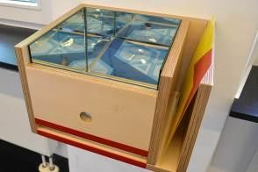  Mirror Box – Infinite patterns  Slide patterns into slot and view infinite patterns. | Infinite patterns  Put on of the pictures through the slit into the mirror box. See the beautiful patterns reflected. | Put one of the pictures through the slit into the mirror box. See the beautiful patterns reflected.  Can you see two types of reflection? Can you find a rotation of the original image?  Is there a pattern to the rotations and reflections? Do the mirrors create all possible rotations and reflections? | The mirror box creates an infinite tiling, using reflections and reflections-of-reflections. Students may just want to enjoy the patterns. However, you may want to examine which reflections are left-to-left reflections, which are top-to-bottom reflections, and which reflections are a combination of both (which makes a rotation of the original image). Is there a patten to these different types of rotations and reflections? | 2 - 5 minutes
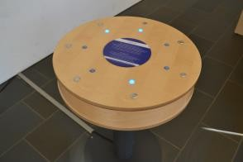  Lights On  Logic problem. Press buttons to turn all lights on. | Lights on!  The goal is to switch on all the lights.  This is always possible with seven or fewer moves. | Experiment with the buttons. What do they do?  Can you turn all lights on? This can always be done in seven or fewer moves.  Does the order you press the buttons matter? Can you describe which states are one move away from solved? Which states are two moves away from solved? | The aim is to turn all lights on. Experiment with the buttons to find out what they do. All lights can be turned on in seven or fewer moves. If a student finds a solution can they do it again? Does the order they press the buttons matter? Each board state is a binary number, and each button is a type of addition, namely XOR addition. | 5 minutes
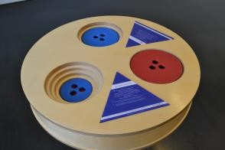  Towers of Ionah  Move all discs from one hole to another. Classic puzzle. | The tower of Ionah  The aim is to move all discs from one hole to another.  Always move one disc at a time.  Never put a smaller disc on top of a bigger one.  What is the fewest number of moves needed?  Hint: Never put two discs of the same colour together. | Can you move the discs from one hole to another? You can only move one disc at a time. Never put a smaller disc on top of a bigger one.  How many moves did you take to move four discs? Was that the fewest number of moves possible?  How many moves would it take to move five discs? How many moves would it take in general? | This puzzle is an inverted version of the classic Tower of Hanoi puzzle. The puzzle solves automatically if you don’t place two discs of the same colour together. For four discs the puzzle can be solved in 15 moves. Can the student solve the puzzle as efficiently as possible? | 5 minutes
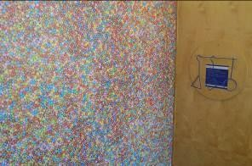  How Many Smarties  Estimation and sampling problem. Take guesses. Uses frames to take a sample. | The Smarties  Estimate the total number of smarties by using the frames to count a sample. Which frame do you think is the best choice? | How many smarties do you think are on this poster? How many blue smarties are on this poster?  Can you use the frames provided to estimate the total number of smarties? Which frame do you think is the best choice?  Survey as many people as possible on what they think. What are the range of answers? Using your data, what is your best estimate? | The question is simple: how many smarties? You could start with a discussion, and taking a few guesses. What was the largest guess? What was the smallest guess? Maybe we can estimate the correct number by taking the average (this is called Wisdom of the Crowd). Use the frames to take a sample. How many frames are need to cover the poster? A frame that covers the poster without gaps is best. What proportion of smarties are blue? | 5 minutes
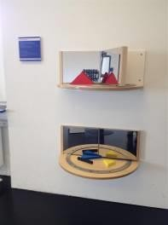  Mirror Book  Move the mirrors to create different patterns and different number of reflections. | A machine for patterns  Put one piece between the mirrors.  How often do you see the piece?  Does the number of images change when you move the mirror?  Using the stick, can you make an octagon? How about a square? | Put one piece between the mirrors. How often do you see the piece? Does the number of images change when you move the mirror?  Using the stick, can you make an octagon? How about a square?  Using the stick, can you make a hexagon? How about a triangle?  Place a coin between the mirrors. Which images are flipped?  Which angles produce finitely many images? Given the angle can you predict how many images you will get? | The Mirror Book allows you to change the angle between two hinged mirrors to create different number of images. How many images can you see at different angles? Can you use the pieces to make a triangle, a square, a hexagon, an octagon? What is the relation between the angle and the number of pieces? If we place a coin between the mirrors which images are flipped? These ideas are used in telescopes, microscopes, cameras and fibre optic cables. | 2 minutes
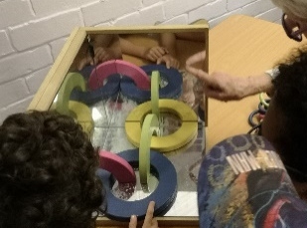  Corner Mirror (12 ring puzzle)  Can the pieces be placed on the mirrors to create a circle of 12 linked rings | 12 rings  Use the corner mirror to recreate the chain of 12 rings shown here [image]  Hint: The rings do not need to lie flat. | Look at the mirrors from different angles. Can you always see yourself?  Close one eye and look at the corner, where is your eye is the mirror? See what happens when you move your head around.  Can you use the corner mirror and pieces to recreate the chain of 12 rings shown in the image? | Look into the corner mirror from different angles. Can you always see yourself? Light that hits all three mirrors reverses direction and is reflected back towards the source. So, light from your eye will return directly to your eye. This idea is used in reflective material and radar.  The 12 Ring problem can be puzzling until you realise the rings do not have to lie flat. | 2 – 5 minutes
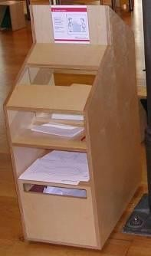  Drawing in the mirror  Can you trace the shapes while only looking in the mirror?  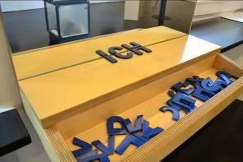  Mirror Letters  Create words with symmetric letters | Drawing in the mirror  Look into the mirror and try to trace the figure on the sheet or write your name! Why is that difficult?  Mirror Letters  Put one of the “half letters” next to the mirror to complete the letter.  Some words are made entirely from mirror letters, such as BOOK, DOCK, BOX.  Can you find more “mirror words”? | Drawing in a mirror: Look into the mirror and try to trace the figure on the sheet or write your name! Why is that difficult?  Mirror Letters: Place the half-letters next to the mirror to complete them. What words can you make from the mirror letters?  Which letters have horizontal symmetry? Which letters have vertical symmetry? Which letters have no line of symmetry? | Drawing in a mirror can be confusing because a mirror reverses depth. Objects that are furthest away from us (and closest to the mirror) appear closest to us. And objects close to us (and furthest from the mirror) appear furthest away in the mirror.  A shape has mirror symmetry if there is a line that divides the shape into two halves that are exact mirror images of each other. Which letters have horizontal symmetry? Which letters have vertical symmetry? Which letters have no lines of symmetry? | 2 – 8 minutes
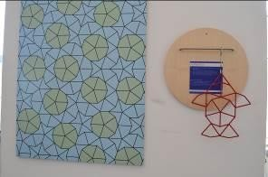  Find the Fish  Use the fish frame to find the fish shape in the poster.  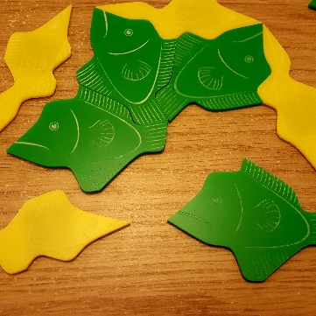  Penrose Fish  Tesselate the magnetic fish to create patterns. | Find the fish  Try to match the fish to the pattern so that it fits completely. There are very few places where this is possible.  This non-repeating pattern is called a “Penrose tiling”.  Tessellation station  Make a tessellation by combining these fish shaped tiles.  These are called “Penrose tiles” and they create non-repeating patterns. | Try to match the fish to the pattern so that it fits completely. How many fish can you find? What is their pattern?  How many different shapes make up the poster pattern?  The poster uses seven different configurations around a point. Can you find them all? Are any possibilities missing? | Use the fish-shaped frame and find the fish in the poster pattern. How many fish can you find? There are five fish, that are all rotations around a point. Normally, tiling patterns repeats themselves – in other words, shifting all the tiles across gives the exact same pattern. This pattern is different, it goes on forever in all directions, but the pattern will never exactly repeat itself. This pattern is called a Penrose tiling.  You can make your own Penrose tiling with our Penrose Fish tiles. | 5 - 10 minutes
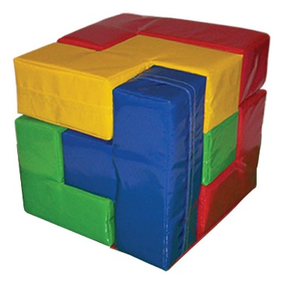  Giant Soma Cube  Make a large cube | Soma Cube  Form a cube out of the seven coloured pieces. There are many different solutions.  Hint: How large will the cube be? | A cube can be made from these seven coloured pieces. Can you work out the size of the cube?  Form a cube out of the seven coloured pieces.  Given a solution, how many different solutions can be obtained from rotating the cube? How many different solutions can be obtained from rotating pieces? | Form a cube from the seven coloured pieces. These pieces are made from 27 unit-cubes, to make a 3×3 cube. There are 240 possible solutions, excluding rotations. All solution can be rotated so the T shape is in the bottom layer, which can be used as a starting point. | 5 – 10 minutes

Following exhibits subject to availability
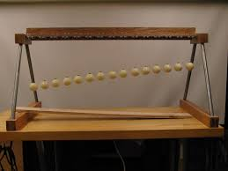  Pendulum Wave  Turn the handle to set the pendulums, and release. Pendulums create patterns as they synchronise. | Pendulum waves  Turn the handle in the direction of the arrow to set the pendulums. Release and observe the beautiful patterns as the pendulum move in and out of synch. | Release the pendulums and observe the beautiful patterns as the pendulum move in-and-out of synch.  What kinds of different patterns do you observe? Make a list of what they are and when they occur.  In one complete cycle, the first four pendulums have done 31, 32, 33 and 34 swings. How many swings have they completed at the halfway point? How many swings have they completed a quarter of the way through? Can you explain some of the patterns you see? | Release the pendulums and watch the beautiful patterns as the pendulums move in-and-out of synch. What kinds of different patterns can you see? When do they occur? Longer pendulums take longer to complete a swing, which is why the pendulums gradually move out of synch. However, at various times, parts of their individual cycles start to coincide. At the end, all pendulums have completed a full number of swings and the pattern starts again. | 2 minutes
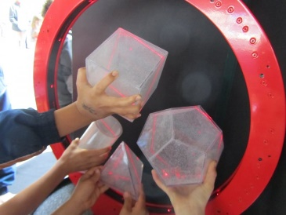  Ring of Fire  Place Perspex shapes into the ring. The laser shows you the cross section. | Ring of fire  Place the shapes in the ring of fire to reveal their cross section.  Can you use the cube to find a triangle? How about a hexagon? | Place the shapes in the ring of fire to reveal their cross section. Which shapes contain a circle? Which shapes contain a triangle?  Can you use the cube to find a hexagon?  Which shape contains the ten-sided decagon? | Find various cross-sectional shapes in the Perspex solids. Some are surprises, such as a rectangle in the cylinder, or a hexagon in the cube. Look for circles, ellipses, triangles, squares, rectangles, pentagons, hexagons and a decagon. | 5 – 8 minutes
Parabolic bounce  Release the ball to hit the focal point. | Parabolic bounce  Drop the ball on the parabola and it will always hit the same mark, known as the focal point. | Drop the ball on the curve, can you get it to hit the bell?  Is there any position where it doesn’t hit the bell?  Have you seen this shape anywhere before? | Drop a ball anywhere onto the parabola and it will always hit the bell. A parabola is special because a ball is always reflected towards the focal point. This is why radio telescopes and satellite dishes are made in this shape. Car headlights use this idea in reverse by placing a light at the focal point which is then reflected outwards as a beam of light. | 3 minutes
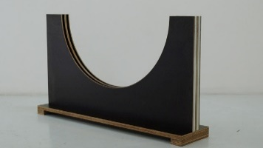  Racing Discs  Release two discs from any two points on opposite sides. They will always reach the middle at the same time. | Racing Discs  Release the two discs from opposite ends of the curve. Where do they meet? Try again, but release the discs from different positions. Where do they meet this time? | Release two discs from opposite ends of the curve. Which disc will reach the bottom first?  Try again, but release the discs from different positions. Which disc will win the race this time?  Can you think of any applications for this special curve? | Release two discs and see which disc reaches the bottom first. You will see they reach the end at the very same time. Try again, but release the discs from different positions. They will reach the end at the same time again. In fact, it takes the same time to reach the end wherever you release the disc. This curve was discovered in the early days of clocks as a way to keep time, although the design is rarely used. | 3 minutes
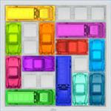  Rush hour game  Puzzle. Slide the red car out of the traffic jam. | Rush hour  Slide the blocking vehicles out of the way for the red car to exit. |  |  | 5 – 10 minutes
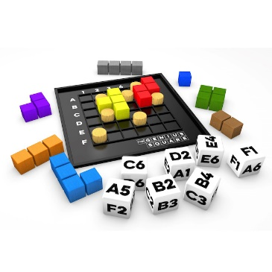  Genius Square  Place the blockers (pegs) on the grid. (Optionally, use the dice to determine placement). Fill the remaining space with tetris shapes. Race a friend. | Genius square  Use the dice to position seven “blockers” on the board. Can you complete the square using the nine coloured shapes?  Use the second board to race your friends. There will always be at least one solution. |  |  | 5 minutes
Ipad (puzzle app) and stand.  Stand may be knocked over if not fixed. |  |  |  | 3 – 10 minutes

