Explore Maths
Hands-on Mathematics Exhibition from MathsWorldUK
Give your maths output an added WOW factor with Explore Maths, an interactive exhibition touring science discovery centres and art spaces from 2020.
Explore Maths invites all visitors to take a first-step into the world of mathematics.  The exhibition contains over 20 activities, all made to discovery centre quality, and developed with Mathematikum, Germany’s national mathematics discovery centre.  The exhibition allows people of any age, ability and background to explore mathematics in a positive and relaxed atmosphere. |  | 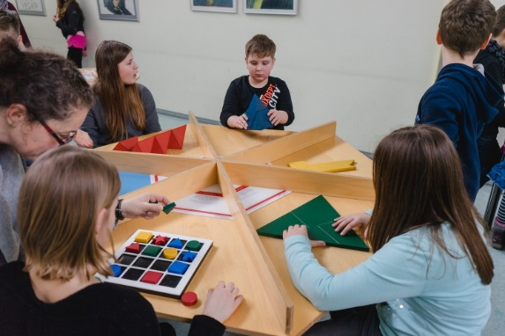  High quality activities from Mathematikum
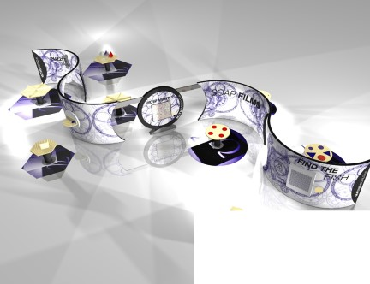  Explore Maths Concept Art November 2019 | The exhibition is made from plywood to create a visually stunning ribbon. It features several mounted activities and eight table activities.  Three cut-out circles allow people to move freely between activities, including wheelchairs. Other arrangements are possible, such as installing the ribbon as two halves.  The exhibition can be manned or unmanned. Staff training is provided by our tour manager. A teacher’s guide will also be provided, to allow teachers to lead their own groups.
The exhibits: All the exhibits are inviting and can be attempted by all ages. Some activities are demonstrations, some are investigations and some are hands on puzzles with a low entry threshold. The exhibits have been deployed successfully in discovery centres on the continent.
Curriculum links: The exhibition supports mathematical reasoning and problem solving skills. This includes hands-on experience of shape, estimation, probability and multi-step problems.
Footprint: 12m × 21m including tables and floor mats. Height 2.55m. Other arrangements are possible.
Installation time: 1 day
Costs: £3000 (travel and installation costs only)
Target age: Family friendly with activities even toddlers can take part in and adults can be absorbed by. Mathematically accessible to Y5-Y8 school parties.
Group size: 30-40 (60 max)
Duration: 60 minutes
Tour manager: Dr James Grime has worked in maths communication for 12 years. James was a curator of the Fitzwilliam Museum’s Codebreakers exhibition in 2018, and is a public speaker on mathematics. As well as staff training, James can give a public talk at your venue as an additional event. We are also happy to co-organise other events with you around the exhibition.
Contact information: For more information, or to book Explore Maths, contact James at email@jamesgrime.com

